A practical guidance - 2: Schedules 1 to 10
Revision 1 September ‘25

Schedule of lifts for Tower Crane
Please note:
This document has been provided by Sir Robert McAlpine Limited. It has been checked to the best of our ability but may contain unintentional errors. As per BS 7121-1:2016, CDM 2015 and LOLER, it is the user’s responsibility to verify that they understand and have made their own checks before using this document.
The user shall ensure that they properly risk assess and plan their own lifting operations to discharge their legal requirements.
No liability will be accepted for any incidents that result of those using this document.

The schedules
No. | Title:
1. | Timber – Packs of ply
2. | Timber – Bundles, Scaffold boards, 4’ x 2’
3. | Reinforcement – Straight lengths
4. | Reinforcement - Links
5. | Reinforcement – ‘L’-Shape bundles
6. | Reinforcement - Mesh packs
7. | Prefabricated ‘cages’ – Wall sections
8. | Reinforcement - Prefabricated ‘cages’ - Columns
9. | Prefabricated ‘cages’ – Beams
10. | Prefabricated ‘cages’ – Pile capping beams
Ref. | Blank template

Load description: Timber – Packs of ply
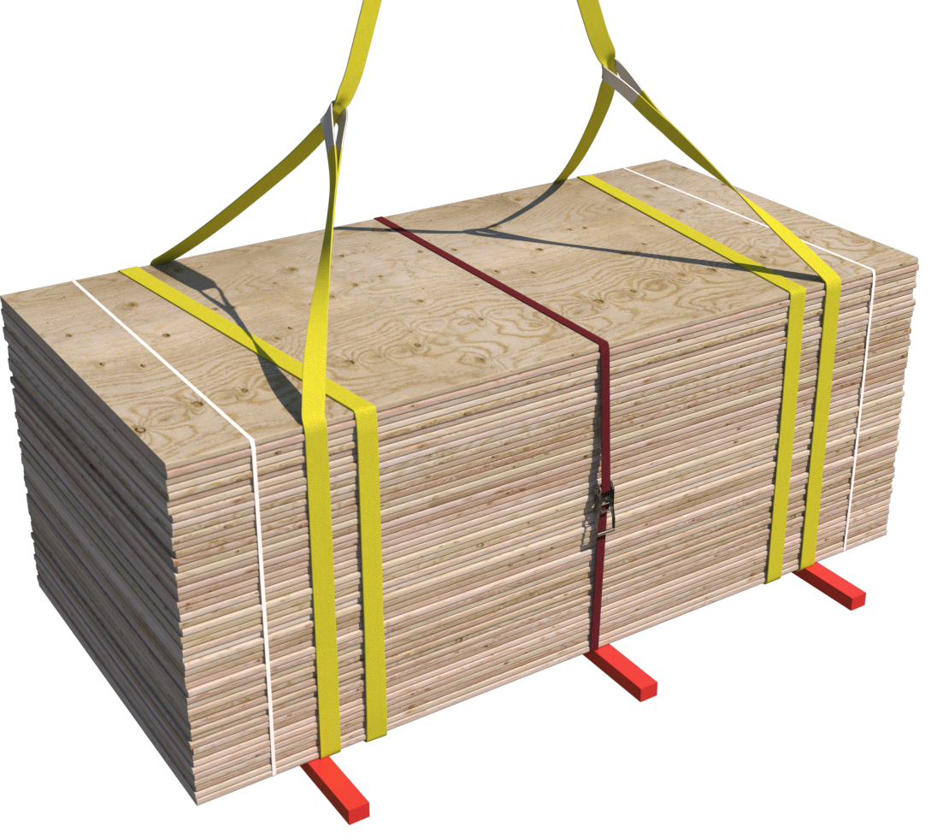 |  | Slinging methodology:  - 4 leg chain slings will be attached to hook block of the crane. Only 2 legs required so any unused chains will be hung back to the master ring.  - 2no. webbing slings min WLL 3 t of sufficient length will be attached to the ply pack in a double wrap – choke configuration.  - Hooks of chain slings will then be attached to the webbing slings.  - Ratchet strap or securing banding to be used around load.
Lift Category: | Basic
Dimensions of load: | Various dimensions: Typically, 1.6m [h] x 2.4m [l] x 1.2m [w] for standard pack of ply
Weight of Load | Typically, 1.6 t for 18mm ply but up to 1.8 t
Lifting accessories used with weights of accessories: | From hook block:  4 Leg chain slings WLL 8.4 t @ 103kg  ----------------------------------------------  2no. webbing slings 10m @ 7kg  Gross weight inc. 10% FOS: 2.101 t |  | WLL x Mode Factor | Resulting SWL
 |  |  | 4 leg chain slings with 2 legs in use - WLL of one leg multiplied by 1.4 = 4.41 t  ----------------------------------------  2 webbing slings used a set in a choke configuration = [WLL of one sling multiplied by 1.4] x .8 = 3.36 t | 3.36 t over all accessories stated
Alternative methodology: | 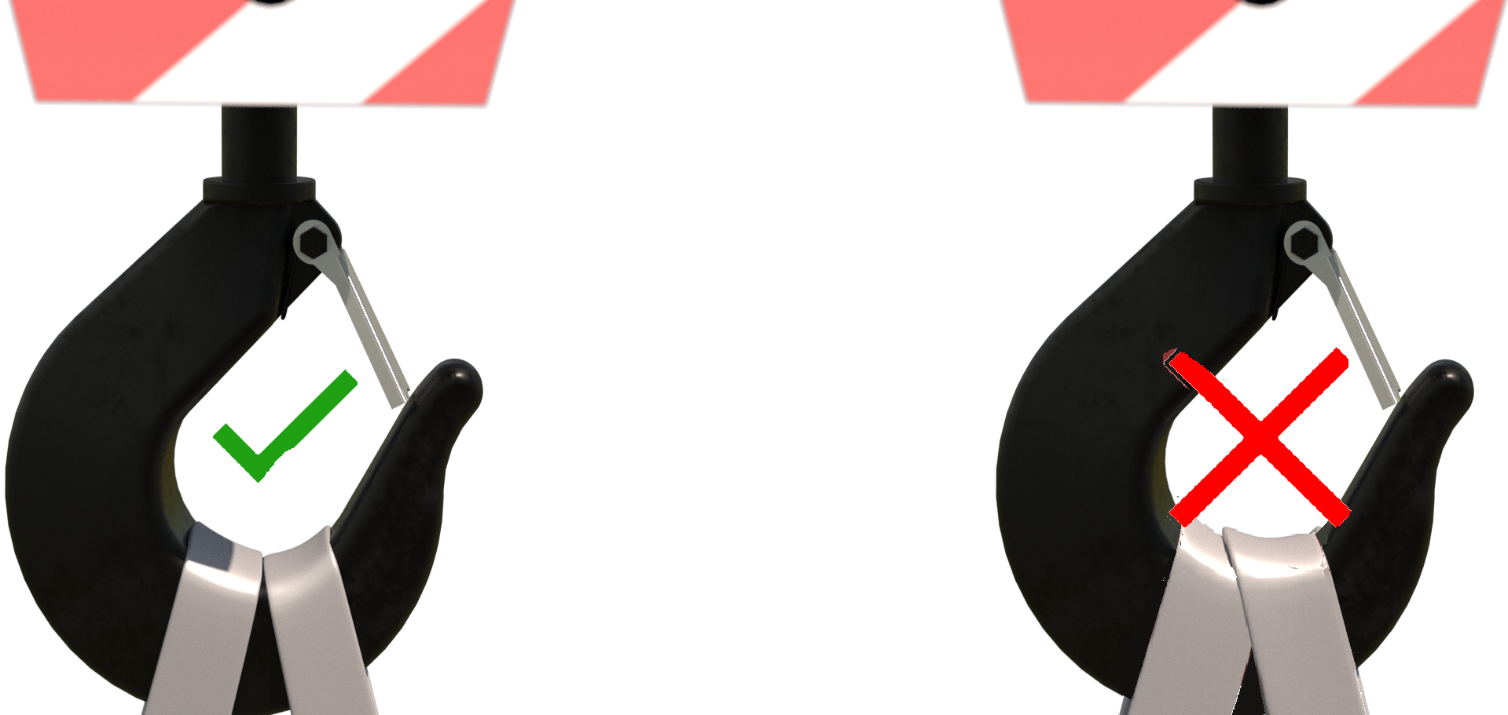If size of hook block allows, then the webbing slings can be directly attached.  DO NOT OVERCROWD THE BLOCK
Safe lifting considerations: | - 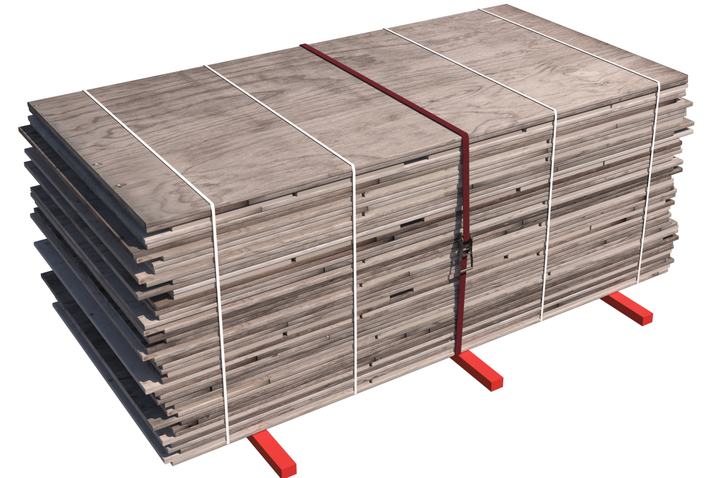Check underside of ply for any materials that may have adhered themselves during transit or storage.  - Securing banding or ratchet strap to be used around the pack.  - When slinging ‘used’ ply ensure that all elements of the load are captured by using securing banding around the pack.  - Check integrity of landed load after removal of accessories in case of collapse.

Load description: Timber - Bundles i.e., Scaffold boards, 4 x 2, 6 x 3, loose timber bundles, etc.
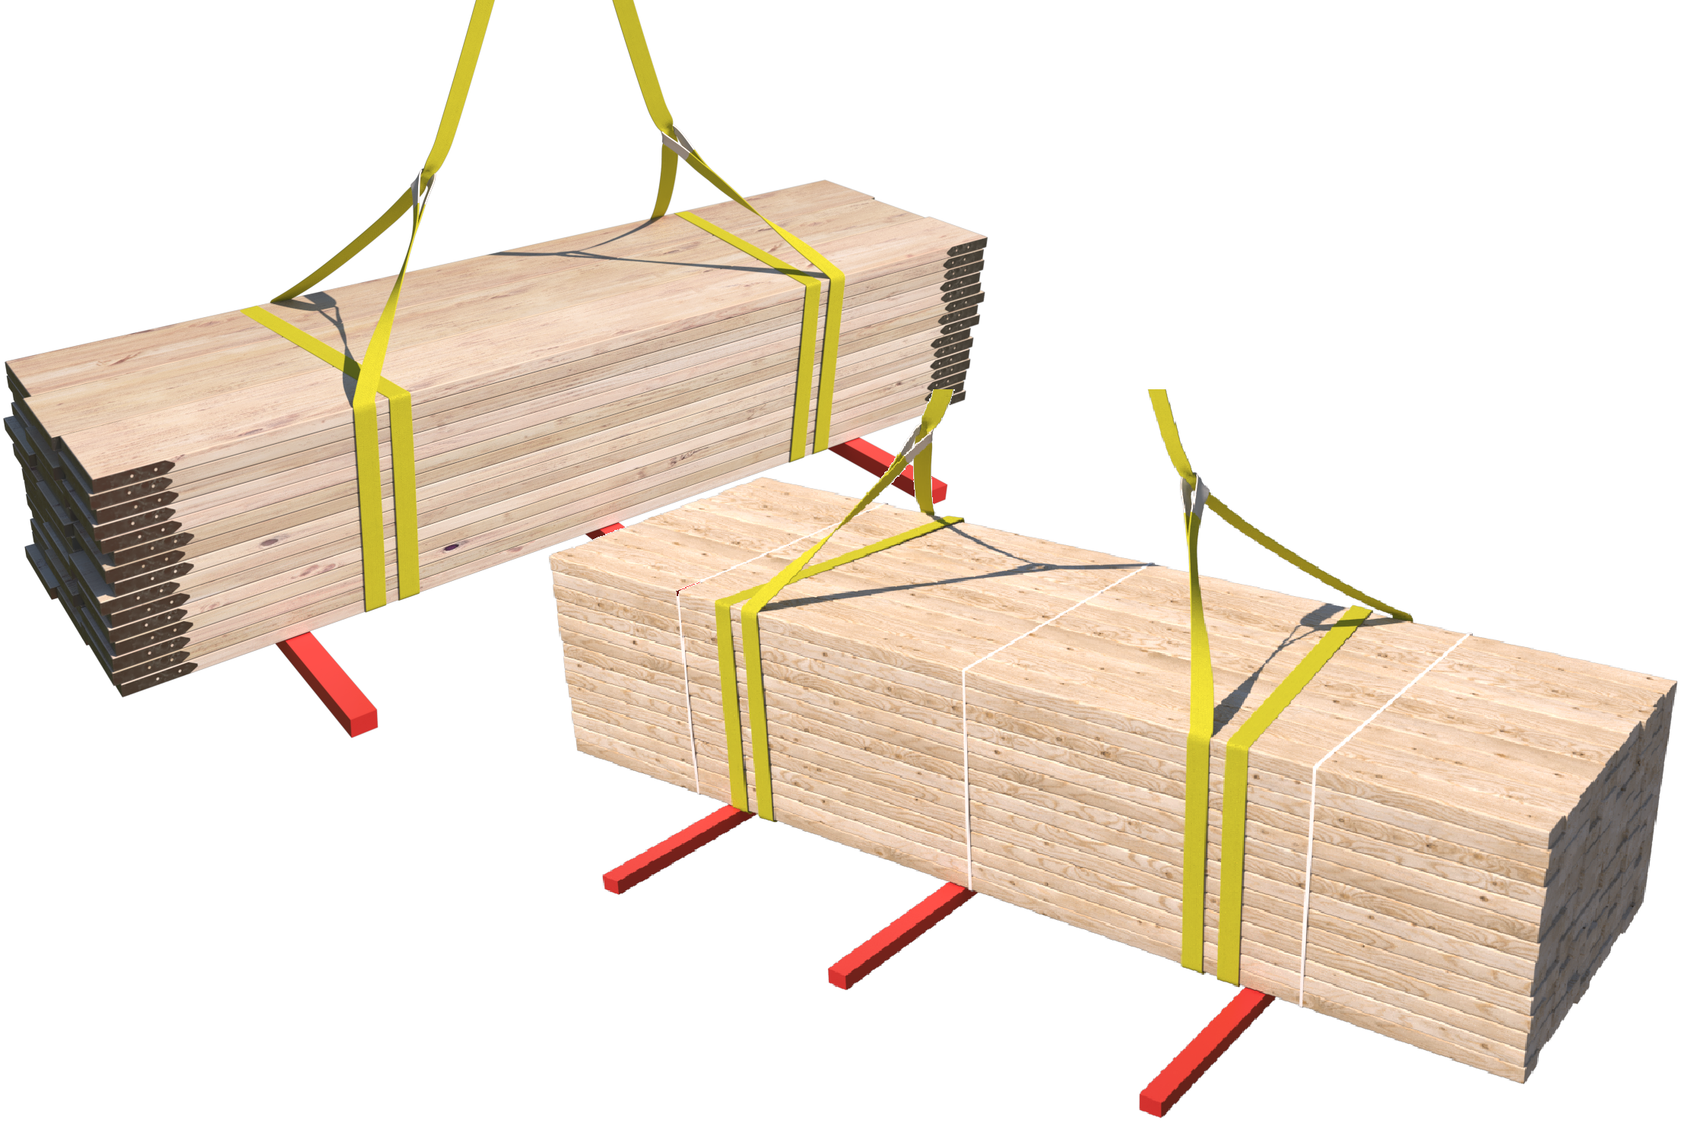 |  | Slinging methodology:  - 4 leg chain slings will be attached to hook block of the crane.  - Any unused chains will be hung back to the master ring.  - 2no. webbing slings min WLL 3 t of sufficient length will be attached to the pack in a double wrap – choke configuration.  - Hooks of chain slings will then be attached to the webbing slings.  - Ratchet strap or securing banding to be used around load.
Lift Category: | Basic
Dimensions of load: | Various dimensions: Typically, 1000mm [h], 1000mm [w] & 4800mm [l] for standard pack of 4’ x 2’ or 6’ x 3’
Weight of Load | Typically, no more than 2.5 t for dimensions given
Lifting accessories used with weights of accessories: | From hook block:  4 Leg chain slings WLL 8.4 t @ 103kg  ----------------------------------------------  2no. webbing slings 10m @ 7kg  Gross weight inc. 10% FOS: 2.871 t | WLL x Mode Factor | Resulting SWL
 |  | 4 leg chain slings with 2 legs in use - WLL of one leg multiplied by 1.4 = 4.41 t  ----------------------------------------  2 webbing slings used a set in a choke configuration = [WLL of one sling multiplied by 1.4] x .8 = 3.36 t | 3.36 t over all accessories stated
Alternative methodology: | If size of hook block allows, then the webbing slings can be directly attached.  DO NOT OVERCROWD THE BLOCK
Safe lifting considerations: | - Check underside of load for any materials that may have adhered themselves during transit or storage.  - Securing banding or ratchet strap to be utilised around the load.  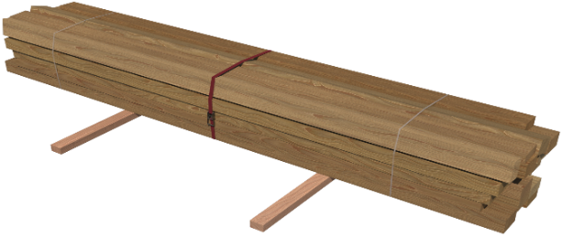  - Check integrity of landed load after removal of accessories in case of collapse.  - When slinging ‘used’ timbers ensure that all elements of the load are captured by utilising securing banding or ratchet strap around the pack.

Loads description: Reinforcement – Straight lengths
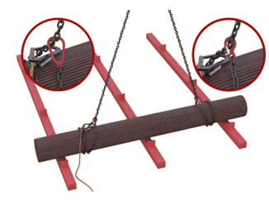 |  | Slinging methodology:  - 4 leg chain slings will be attached to hook block of the crane. Only 2 legs are required so any unused chains will be hung back to the master ring.  - 2 legs of the chain sling will be attached to the load in a double wrap - choke configuration.  - Do not lift from tying wire
Lift Category: | Basic
Dimensions of load: | Typically, in lengths from 6m to 12m with diameters of 500mm
Weight of Load | Typically, 2.5 t for 12m lengths of 25mm reinforcement
Lifting accessories used with weights of accessories: | From hook block:  4 Leg chain slings WLL 8.4 t @ 103kg  Gross weight inc. 10% FOS: 2.863 t | WLL x Mode Factor | Resulting SWL
 |  | 4 leg chain slings with 2 legs in use in a choke configuration – [WLL of one leg multiplied by 1.4] x .8 = 3.528 t | 3.528 t Over all accessories stated
Alternative methodology: | 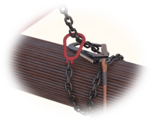  Collar chains can be used around the load in the same configuration. min WLL 3.15 t ea.
Safe lifting considerations: | - Check the bundle for any short lengths of reinforcement that are not captured by the accessories.  - Sling to suit a level load along the length of the bundle. Where necessary a third chain can be employed to achieve the level configuration. i.e., third chain used in the middle of the load to minimise ‘sagging’ to allow a safe landing.  - When landing the load ensure that suitable timbers/chocks are employed to enable a safe re-slinging of the load.  - Leave a suitable gap between landed bundles to ensure a safe access to re-sling. Considerations are to be made to the spread of the load when securing wire is removed.  - Do not stack bundles more than 2 bundles high and ensure that timbers of suitable strength and length are employed to enable safe stacking.  - When landing loads ensure enough room is left between the bundles to allow for safe access for slinger when slinging again.

Loads description: Reinforcement - Links
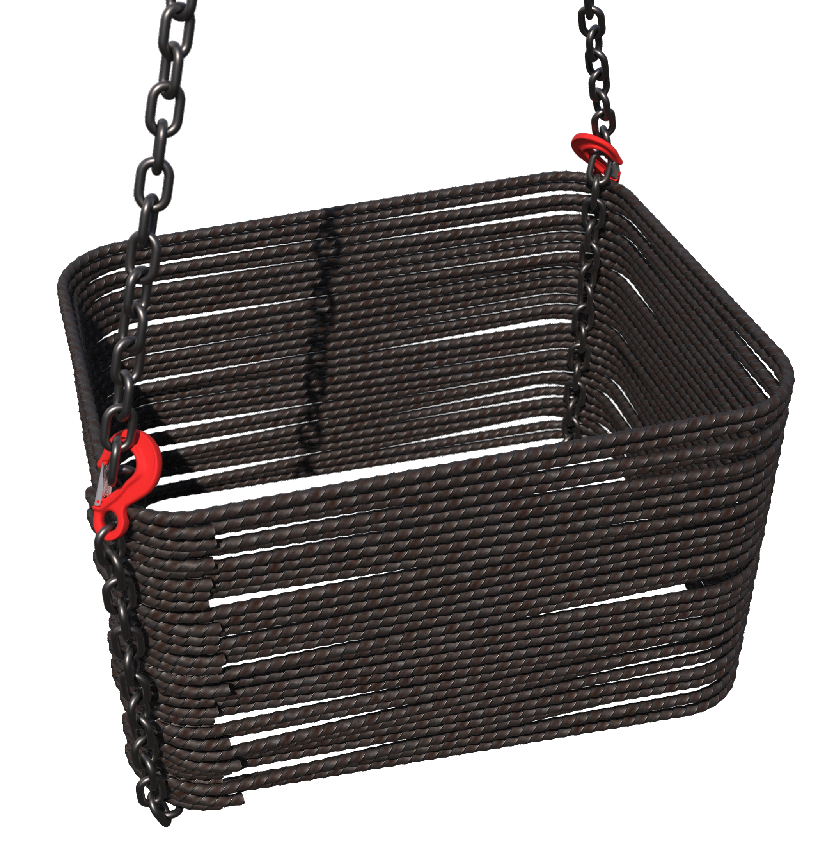 |  | Slinging methodology:  - 4 leg chain slings will be attached to hook block of the crane. Only 2 legs are required so any unused chains will be hung back to the master ring.  - 2 legs of the chain sling will be attached to the load in a single wrap – captured choke configuration.  - Do not lift from tying wire
Lift Category: | Basic
Dimensions of load: | Various with no typical sizes
Weight of Load | Typically, no more than 2 t
Lifting accessories used with weights of accessories: | From hook block:  4 Leg chain slings WLL 8.4 t. @ 103kg  Gross weight inc. 10% FOS: 2.313 t | WLL x Mode Factor | Resulting SWL
 |  | 4 leg chain slings with 2 legs in use in a choke configuration – [WLL of one leg multiplied by 1.4] x .8 = 3.528 t | 3.528 t Over all accessories stated
Alternative methodology: | Collar chains can be used around the load in the same configuration. min WLL 3.15 t ea.  Additionally, 4 legs of chain sling can be used at each corner of the links bundle in a choke configuration
Safe lifting considerations: | - When landing the load ensure that suitable timbers/chocks are employed to enable a safe re-slinging of the load.  - Leave a suitable gap between landed bundles to ensure a safe access to re-sling.  - Link bundles are not to be stacked atop each other or other loads.  - Sling bundles to suit a level configuration.

Loads description: Reinforcement – ‘L’-Shape bundles
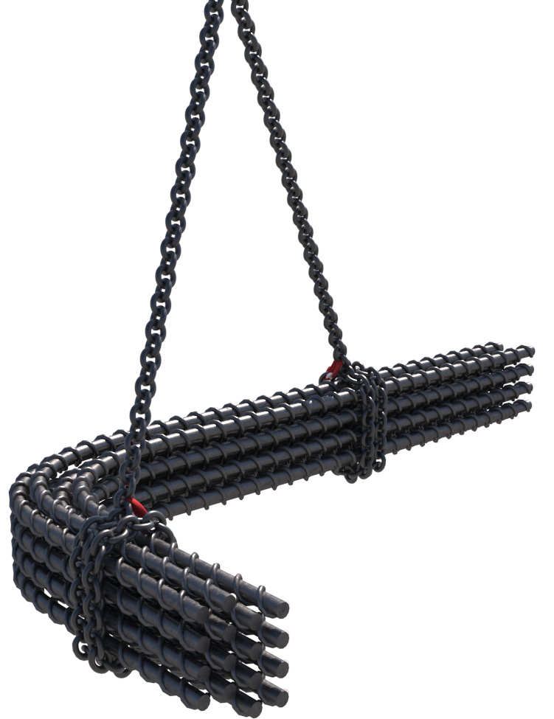 |  | Slinging methodology:  - 4 leg chain slings will be attached to hook block of the crane. Only 2 legs are required so any unused chains will be hung back to the master ring.  - 2 legs of the chain sling will be attached to the load in a double wrap – choke configuration.  - Spacing of the chains to suit a level load.  - Do not lift from tying wire
Lift Category: | Basic
Dimensions of load: | Various with no typical sizes
Weight of Load | Typically, no more than 2 t
Lifting accessories used with weights of accessories: | From hook block:  4 Leg chain slings WLL 8.4 t @ 103kg  Gross weight inc. 10% FOS: 2.313 t | WLL x Mode Factor | Resulting SWL
 |  | 4 leg chain slings with 2 legs in use in a choke configuration – [WLL of one leg multiplied by 1.4] x .8 = 3.528 t | 3.528 t Over all accessories stated
Alternative methodology: | 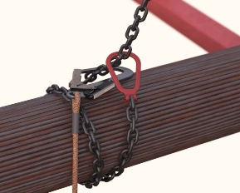  Collar chains can be used around the load in the same configuration. min WLL 3.15 t ea.
Safe lifting considerations: | 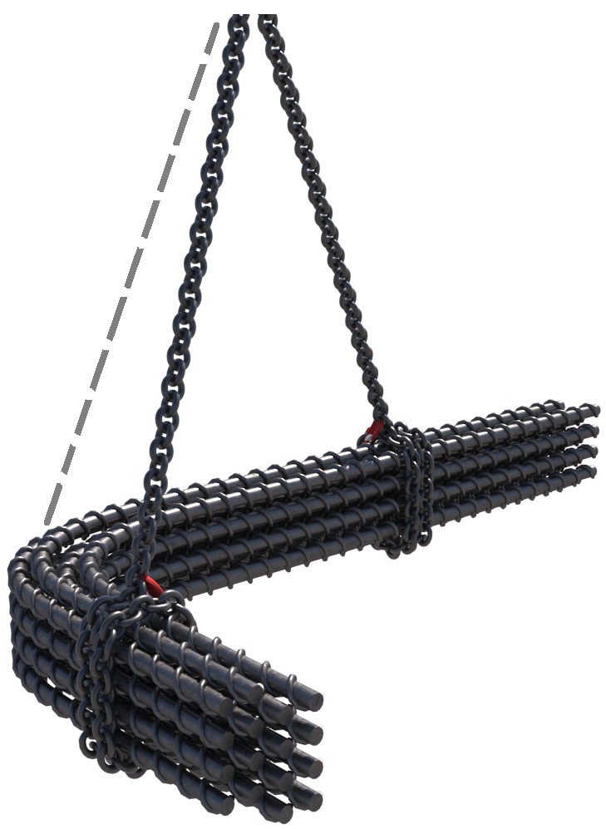  - When landing the load ensure that suitable timbers/chocks are employed to enable a safe re-slinging of the load.  - Leave a suitable gap (600m) between landed bundles to ensure a safe access to re-sling.  - Sling bundles to suit a level configuration. Where necessary a third chain can be employed to achieve the level configuration.  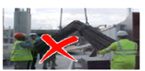Please note:  Bundles are not to be slung so that the ends of the bundles are facing either downwards or upwards.  Slinging in this configuration will make landing problematic due to load ‘tipping’ when landing.

Loads description: Reinforcement - Mesh packs
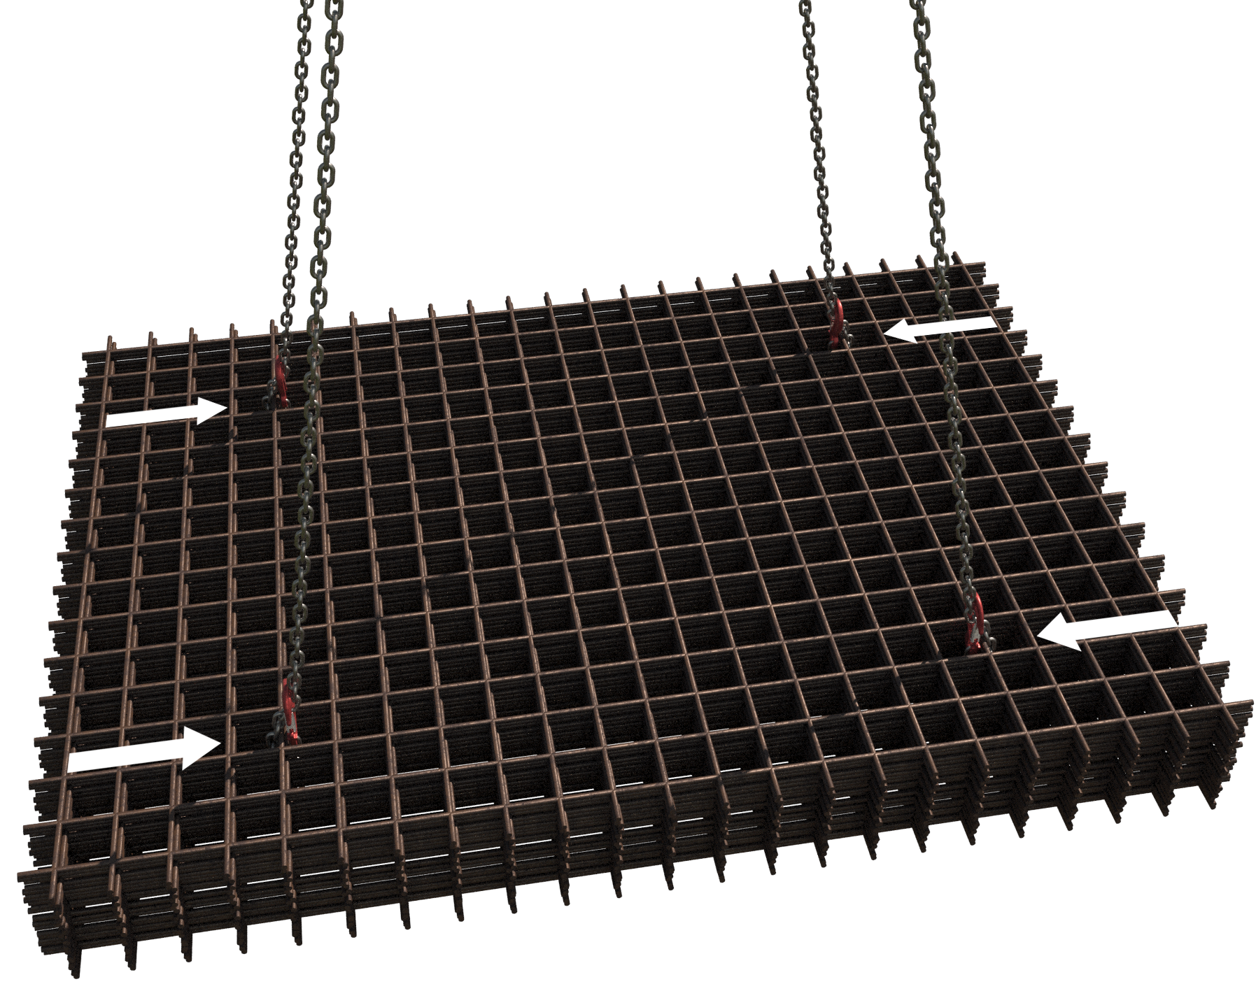Hook attachment to be at interserction of the 5th cross and the 3rd line wire |  | Slinging methodology:  - 4 leg chain slings will be attached to hook block of the crane.  - Chain slings will be attached through the pack of mesh in a captured choke configuration.  - Placement of the chains should be at the intersections of the 5th cross wire and the 3rd line wire.  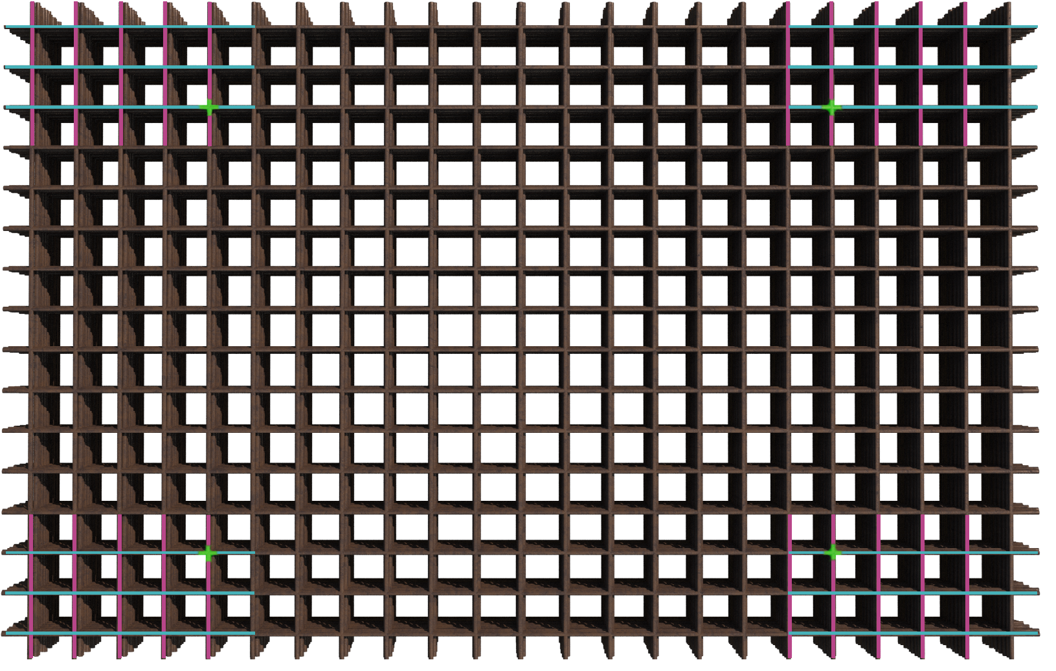  - Do not lift from tying wire.
Lift Category: | Basic
Dimensions of load: | Typically, 2400mm [w] x 4800mm [l] x 6000 mm [ h]
Weight of Load | Typically, 2.3 t for fifty sheets of A393 mesh sheets
Lifting accessories used with weights of accessories: | From hook block:  4 Leg chain slings WLL 8.4 t @ 103kg  Gross weight inc. 10% FOS: 2.644 t [ru] | WLL x Mode Factor | Resulting SWL
 |  | 4 leg chain slings with 4 legs in use – WLL multiplied by .8 = 6.72 t | 6.72 t over all accessories stated
Alternative methodology: | Collar chains or can be used around the load in the same configuration. min WLL 3.15 t ea.  Please note:  Some pre-slung packs are slung with short wire bonds. Ensure prior to lifting that they are positioned as per the diagram above and that they are of sufficient WLL after mode factors considered to lift the load
Safe lifting considerations: | - When landing the load ensure that suitable timbers/chocks are employed to enable a safe re-slinging of the load.  - Leave a suitable gap between landed stacks to ensure a safe access to re-sling.  - Do not stack mesh more than 1500mm in height to avoid the ends of the mesh at head height.  - Utilise protective covering at mesh ends when landed.

Loads description: Reinforcement - Prefabricated ‘cages’ – Wall sections
Special note:
Following images & descriptions are examples of ‘common’ lifting arrangements utilized for these lifts.
Please refer to local TW’s design and confirmed arrangements to define configuration of lift
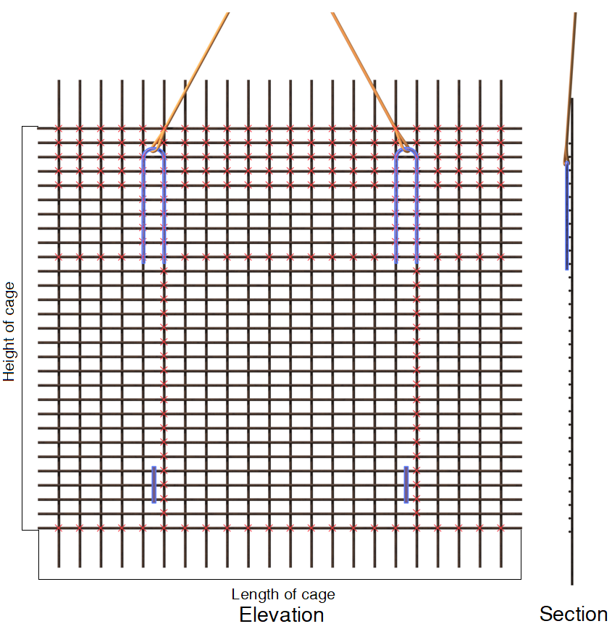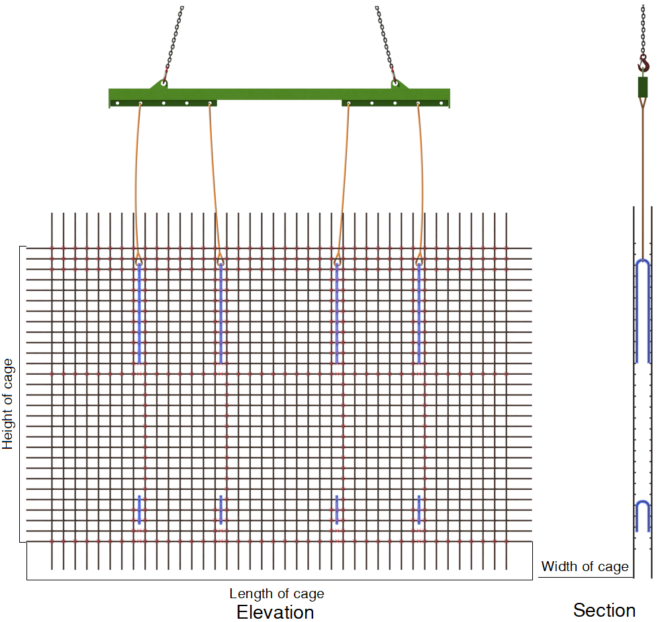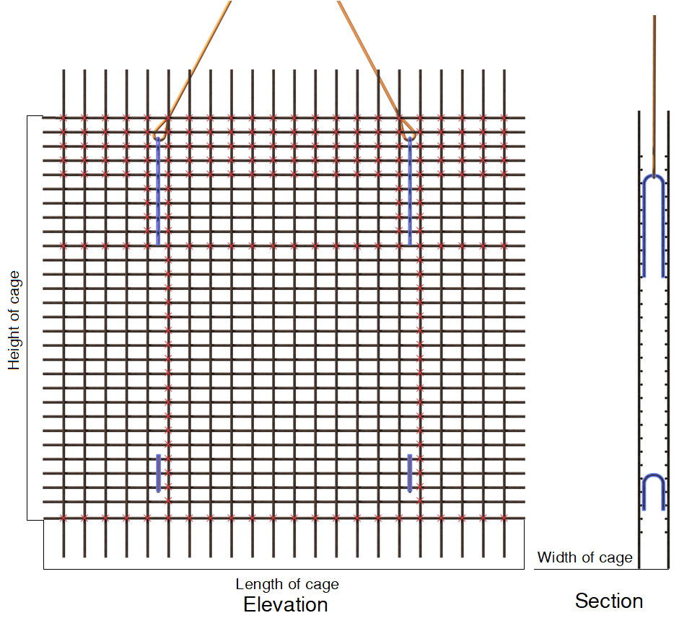  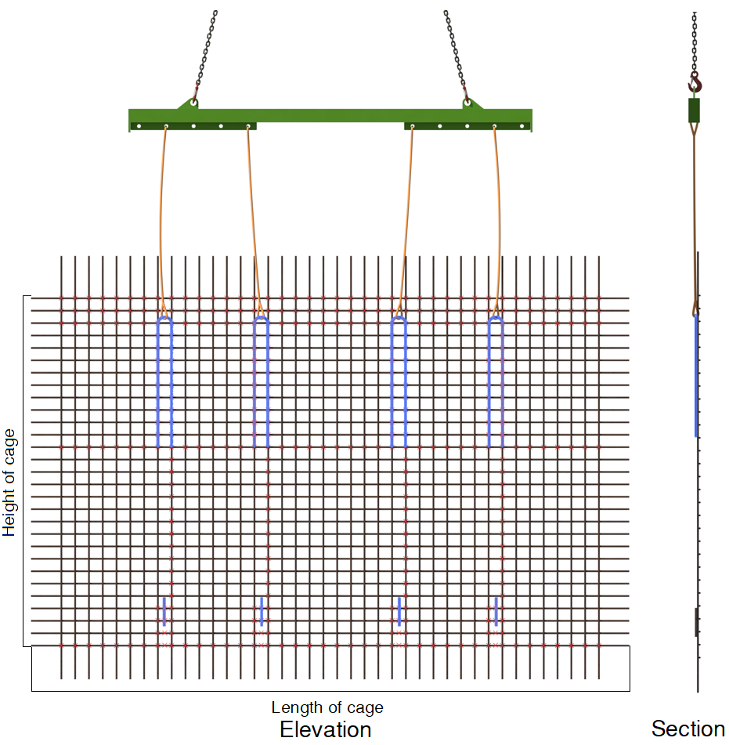 |  | Slinging methodology: Double skinned walls  [typically for double skin walls < 4m long]  - Check cage has TW confirmation of ‘able to lift’  - Attach 4 leg chain sling to hook block of crane. 2 legs only in use so hang spares back to the master ring.  - Feed chains through wall section and attach to identified lifting points as per TW design for the cage.  Slinging methodology: Single skinned walls  [typically for single skin walls < 4m long]  - Check cage has TW confirmation of ‘able to lift’  - Attach 4 leg chain sling to hook block of crane. 2 legs only in use so hang spares back to the master ring.  - Feed chains through wall section and attach to identified lifting points as per TW design for the cage.  Slinging methodology: Double skinned walls  [typically for double skin walls > 4m long]  - Check cage has TW confirmation of ‘able to lift’  - Attach 4 leg chain sling to hook block of crane. 2 legs only in use so hang spares back to the master ring.  - Attach hooks of chain sling to attachment points of lifting beam/frame.  - Raise beam to allow safe attachment of ancillary accessories from underside of lifting beam/frame.  - Feed ancillary accessories through the wall section and attach to identified lifting points as per TW design for the cage  Slinging methodology: Single skinned walls  [typically for single skin walls > 4m long]  - Check cage has TW confirmation of ‘able to lift’  - Attach 4 leg chain sling to hook block of crane. 2 legs only in use so hang spares back to the master ring.  - Attach hooks of chain sling to attachment points of lifting beam/frame.  - Raise beam to allow safe attachment of ancillary accessories from underside of lifting beam/frame.  - Attach ancillary accessories to identified lifting points as per TW design for the cage
Lift Category: | Intermediate
Dimensions of load: | Various dimensions over assorted designs: _mm [w] x _mm [h] x _mm [l]
Weight of Load | Various weights over assorted designs _ t
Lifting accessories used with weights of accessories: | Direct attachment:  From hook block >  4 Leg chain slings WLL 8.4 t @ 103kg  Gross weight inc. 10% FOS: _t  ------------------------------------------------  Ancillary attachment via Lifting beam/frame:  From hook block >  4 Leg chain slings WLL 8.4 t @ 103kg  ------------------------------------------------  _m Lifting beam /frame WLL @ _t  [list ancillary accessories here giving lengths, weights & WLL]  Gross weight inc. 10% FOS: _t | WLL x Mode Factor | Resulting SWL
 |  | 4 leg chain slings with 2 legs in use in direct attachment = WLL of one multiplied by 1.4 = 4.41 t  -----------------------------------  4 leg chain slings with 2 legs in use in direct attachment = WLL of one multiplied by 1.4 = 4.41 t  Lifting beam/frame as per designed use  [list ancillary accessories giving mode factors employed to the WLL] | 4.41 t over all accessories stated  -----------------------  _ t over all accessories stated
Alternative methodology: | Various methodologies can be used but note that all alternative methodologies should have gone a TW’s approval process and confirmed that lift can take place.
Safe lifting considerations: | - Ensure the attachment points for the accessories have been clearly identified and that a TWC approval for lifting is in place.  - Check attachment points and surrounding areas for any loose tying wire connections. If found inform the Lift Supervisor and do not lift.  IF UNSURE OF ATTACHMENT CONSULT THE LIFT SUPERVISOR FOR ADVICE.  - Prefabrication area to be as close as possible to install area to negate lifting the load across project. Minimise distance to be travelled with the wall section.  - When standing the wall section from horizontal to the vertical monitor the position of the block in relation to the bottom of the wall section to keep the wall section from ‘swinging’ when fully raised.  - Constant monitoring and adjustment are to be performed in ‘slew’ and ‘boom’ positioning to allow a safe ‘standing’ of the load  - Attention to be paid to the lower sections of the vertical bars for any unanticipated ‘flexing’ that could cause a spring of the wall or undue swinging  - When using a lifting beam, check the frame for any splits or creases in the structure that could affect integrity of the beam.  - Has the beam been painted lately that could cover up deformities?  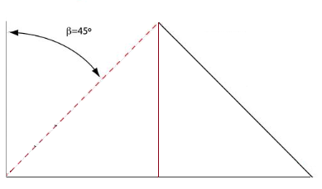  - Ensure the length of the chain sling attaching to the cage & top of the beam is of sufficient length to allow for the chain to be within a 0 to 45 deg. excluded angle.  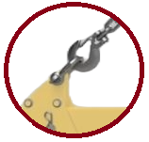  - Ensure the hooks of the chain sling fit into the lifting points situated to the top of the beam. If required use bow shackles, or similar, to affect a correct attachment of the crane chain slings.  - Ensure the ancillary accessory attachment and arrangement to the underside of the beam is ‘like for like’ and uniform in dimension and WLL.  DO NOT MIX & MATCH THE ACCESSORIES  - Attention to be paid to any ancillary accessories within the wall structure, check path of the accessory to ensure it doesn’t compromise the structure of the wall.  - Ensure scaffold tubes and timbers are not used as load bearing points in any lifting arrangements.
Additional information: | Reference weights:  Reinforcement weight per square meter (Kg/m2)  Bar diameter Bar spacing  100mm 150mm 200mm 250mm  10mm 6.16 kg/m2 4.11 kg/m2 3.08 kg/m2 2.46 kg/m2  12mm 8.88 kg/m2 5.92 kg/m2 4.44 kg/m2 3.55 kg/m2  16mm 15.79 kg/m2 10.53 kg/m2 7.9 kg/m2 6.32 kg/m2  20mm 24.66 kg/m2 16.44 kg/m2 12.33 kg/m2 9.86 kg/m2

Loads description: Reinforcement - Prefabricated ‘cages’ - Column
Following are examples of lifting arrangments, Please refer to local TW’s design and confirmed arrangements for defined configuration of lift.  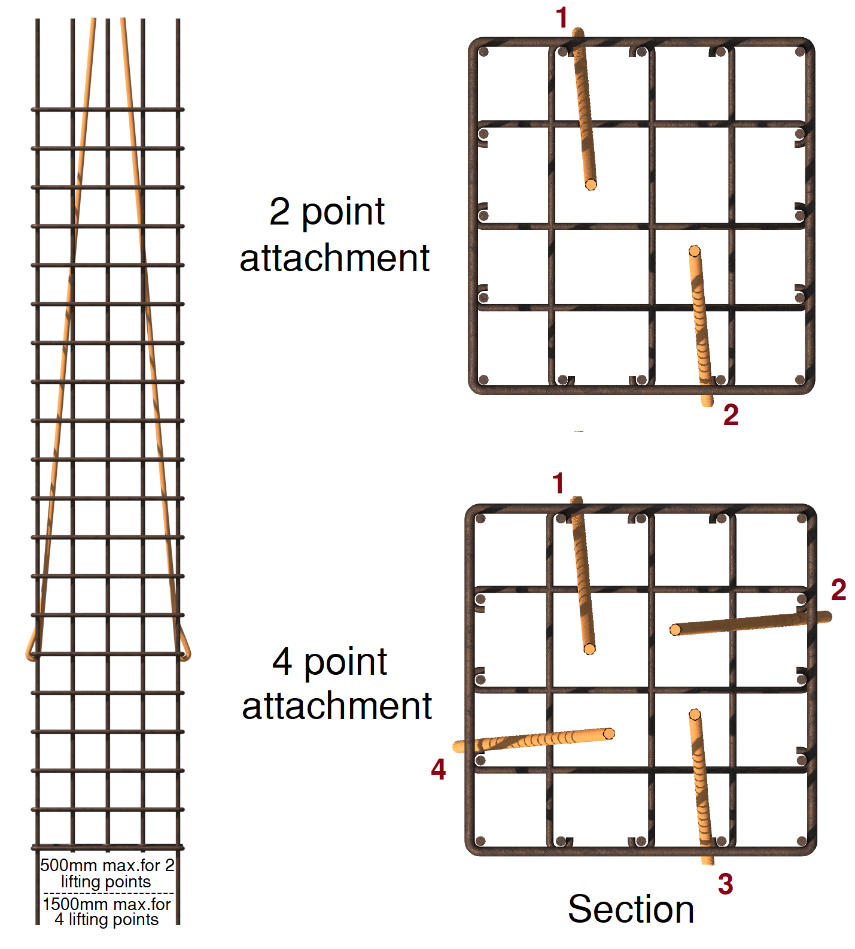‘Square column  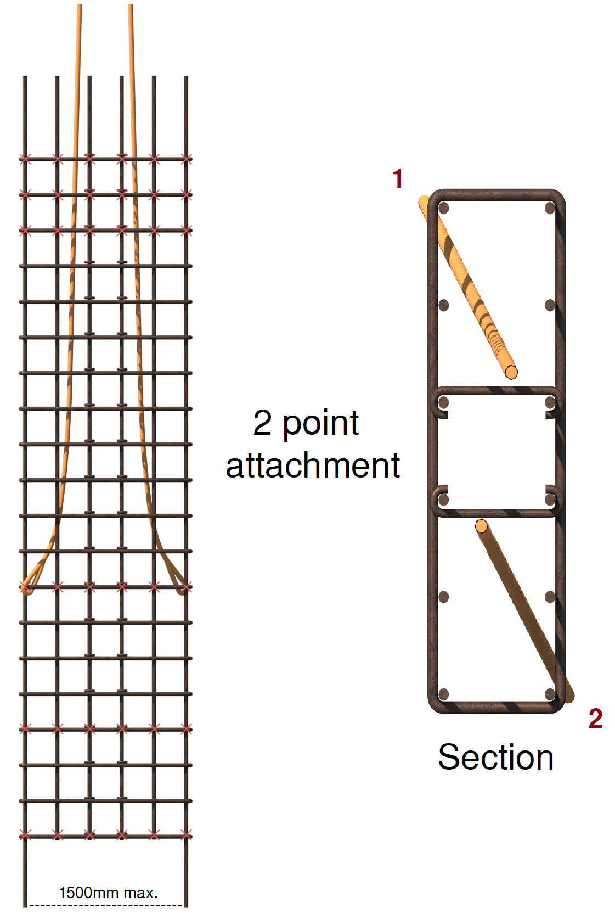  ‘Rectangular column’:  ‘Circular column’  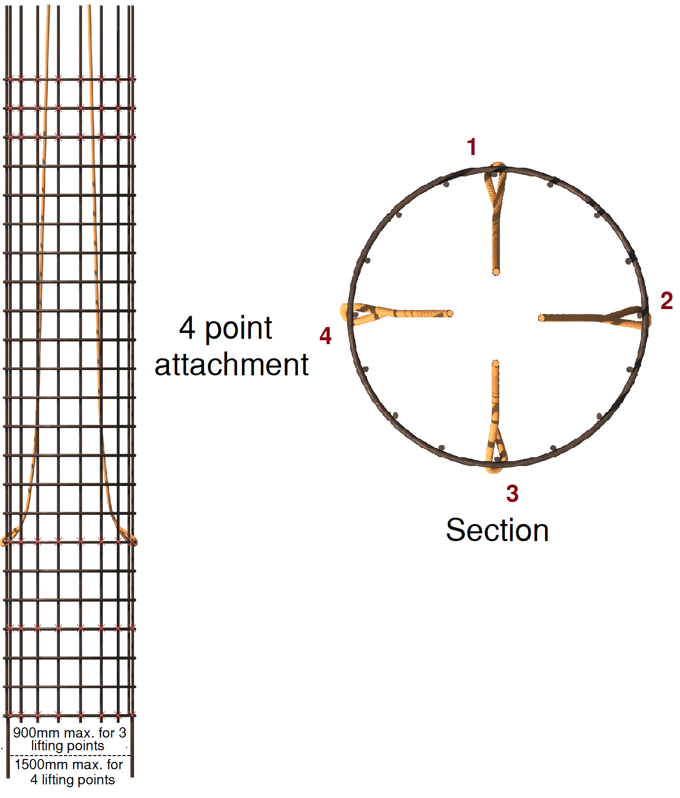 |  | Vertical lifting:  Slinging methodology: - 2 attachment points  [Covering ‘Square’ & ‘Rectangular’ cages]  - Check cage has TW confirmation of ‘able to lift’  - Attach 4 leg chain sling to hook block of crane. 2 legs only in use so hang spares back to the master ring.  - Feed chains through column and attach to identified lifting points as per TW design for the cage.  Slinging methodology: - 4 attachment points  [Covering ‘Square’ and ‘Circular’ cages]  - Check cage has TW confirmation of ‘able to lift’  - Attach 4 leg chain sling to hook block of crane.  - Feed chains through column and attach to identified lifting points as per TW design for the cage.  Horizontal lifting:  - Check cage has TW confirmation of ‘able to lift’  - Attach 4 leg chain sling to hook block of crane. Dependant on design, if only 2 legs are in use, then hang spares back to the master ring.  - Attach hooks of chain sling to the identified lifting points as per TW design for the cage in a choke configuration.  Plan view of example arrangements for horizontal lifting:  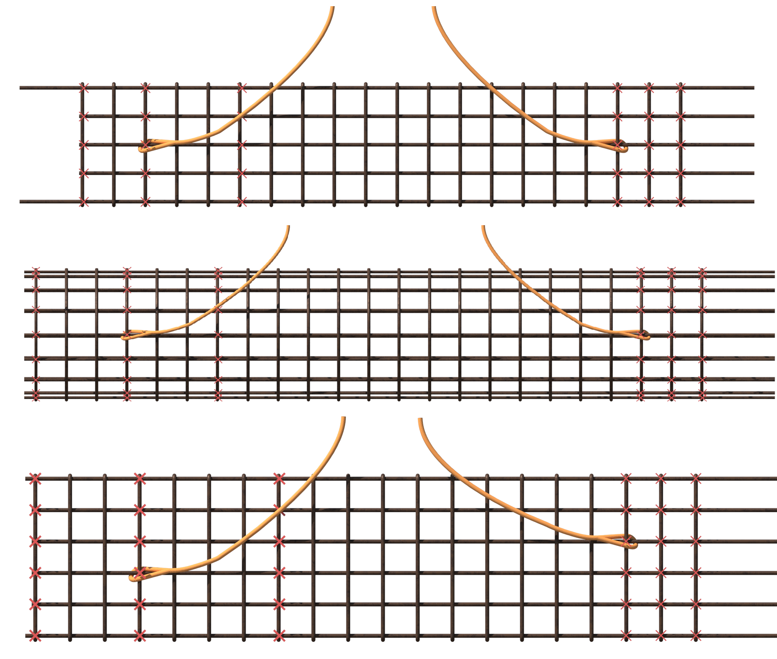
Lift Category: | Intermediate
Dimensions of load: | Various dimensions over assorted designs: _mm [w] x _mm [h] x _mm [l]
Weight of Load | Various weights over assorted designs _ t
Lifting accessories used with weights of accessories: | From hook block >  4 Leg chain slings WLL 8.4 t @ 103kg  Gross weight inc. 10% FOS: _ t | WLL x Mode Factor | Resulting SWL
 |  | 4 leg chain slings with 2 legs in use in a choke configuration – [WLL of one leg multiplied by 1.4] x .8 = 3.528 t  ----------------------------------------  4 leg chain slings with 4 legs in use – WLL multiplied by .8 = 6.72 t | 3.528 t over all accessories stated  ------------------------  6.72 t over all accessories stated
Alternative methodology: | Various methodologies can be used. All must have gone a TW’s approval process by TWC. [Temporary Works Coordinator] and confirmed that lift can take place
Safe lifting considerations: | - Ensure the attachment points for the accessories have been clearly identified and that a TWC approval for lifting is in place.  - Check attachment points and surrounding areas for any loose tying wire connections. If found inform the Lift Supervisor and do not lift.  IF UNSURE OF ATTACHMENT CONSULT THE LIFT SUPERVISOR FOR ADVICE.  - Prefabrication area to be as close as possible to install area to negate lifting the load across project. Minimise distance to be travelled with the column section.  - When standing the column section from horizontal to the vertical monitor the position of the block in relation to the bottom of the column section to keep the column from ‘swinging’ when fully raised.  - Attention to be paid to the accessories within the column structure, check path of the accessory to ensure it doesn’t compromise the integrity of the columns structure i.e., cause ‘rebar’ to bend.  - Constant monitoring and adjustment are to be performed in boom/hook block positioning to allow a safe ‘standing’ of the column  - Attention to be paid to the lower sections of the vertical bars for any unanticipated ‘flexing’ that could cause a spring of the column or undue swinging

Loads description: Reinforcement - Prefabricated ‘cages’ – Beams
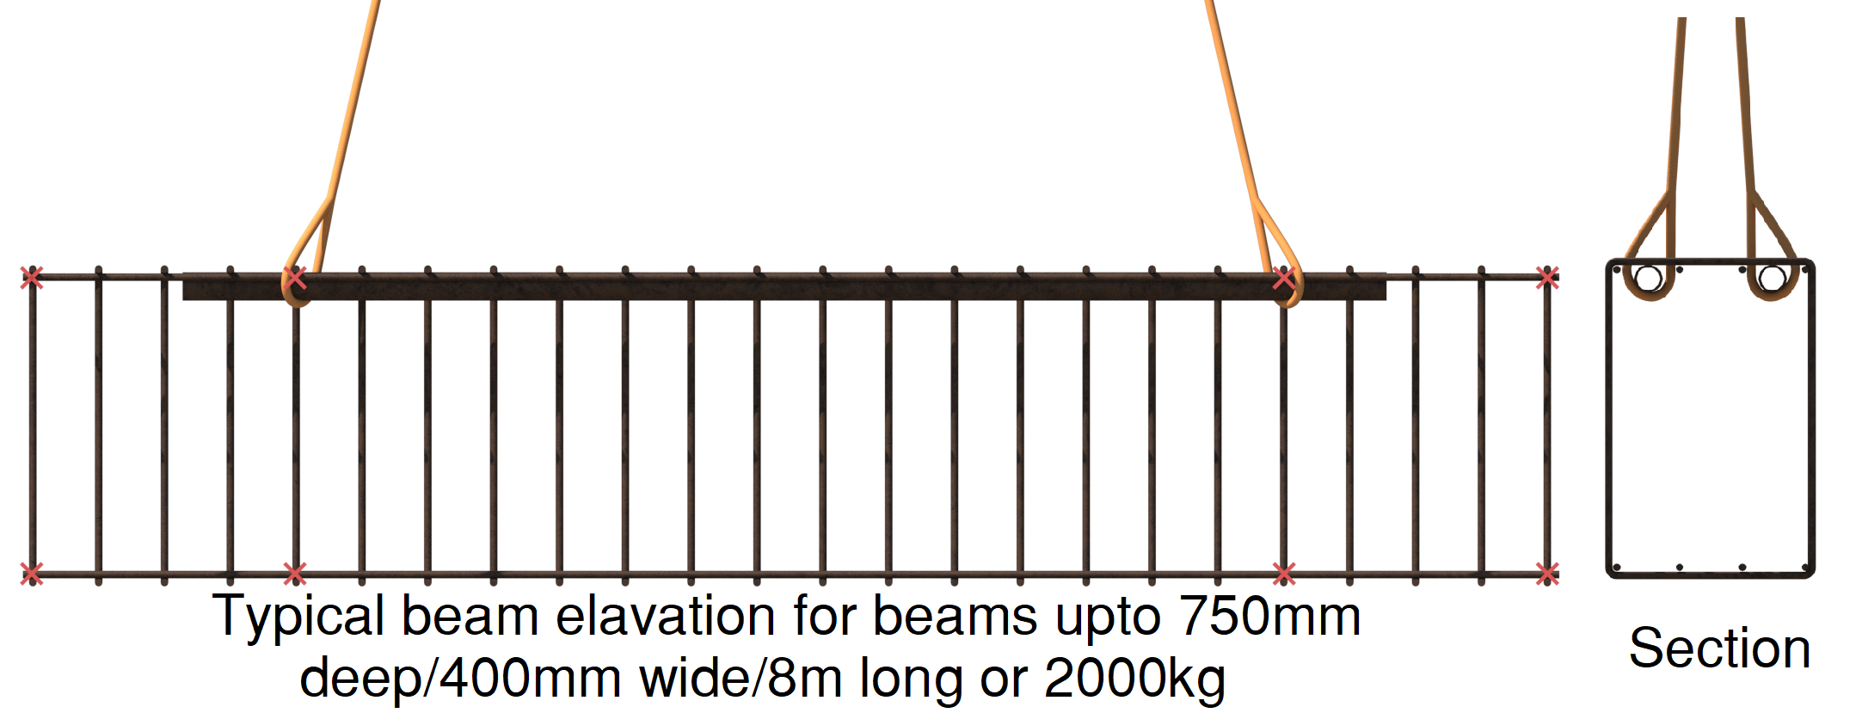 |  | Slinging methodology:  - Check cage has TW confirmation of ‘able to lift’  - Attach 4 leg chain sling to hook block of crane.  - Attach hooks of chain sling to identified lifting points as per TW design for the cage.
Lift Category: | Basic
Dimensions of load: | Various dimensions over assorted designs: _mm [w] x _mm [h] x _mm [l]
Weight of Load | Various weights over assorted designs _ t
Lifting accessories used with weights of accessories: | From hook block >  4 Leg chain slings WLL 8.4 t @ 103kg  Gross weight inc. 10% FOS: _ t | WLL x Mode Factor | Resulting SWL
 |  | 4 leg chain slings as per design use | 8.4 t over all accessories stated
Alternative methodology: | Various methodologies can be used, but all must have gone a TW’s approval process by TWC. [Temporary Works Coordinator]
Safe lifting considerations: | - Ensure the attachment points for the accessories have been clearly identified and that a TWC approval for lifting is in place.  - Check attachment points and surrounding areas for any loose tying wire connections. If found inform the Lift Supervisor and do not lift.  IF UNSURE OF ATTACHMENT CONSULT THE LIFT SUPERVISOR FOR ADVICE.  - Prefabrication area to be as close as possible to install area to negate lifting the load across project. Minimise distance to be travelled with the beams section.  - When locating beams in trench or foundation scenarios ensure there is sufficient space around the beam and adjacent area for safe access to allow placement without putting installation operative at risk of crushing.  - Ensure there is easy access to the attachment points to allow safe removal of accessories

Loads description: Reinforcement - Prefabricated ‘cages’ – Pile capping beams
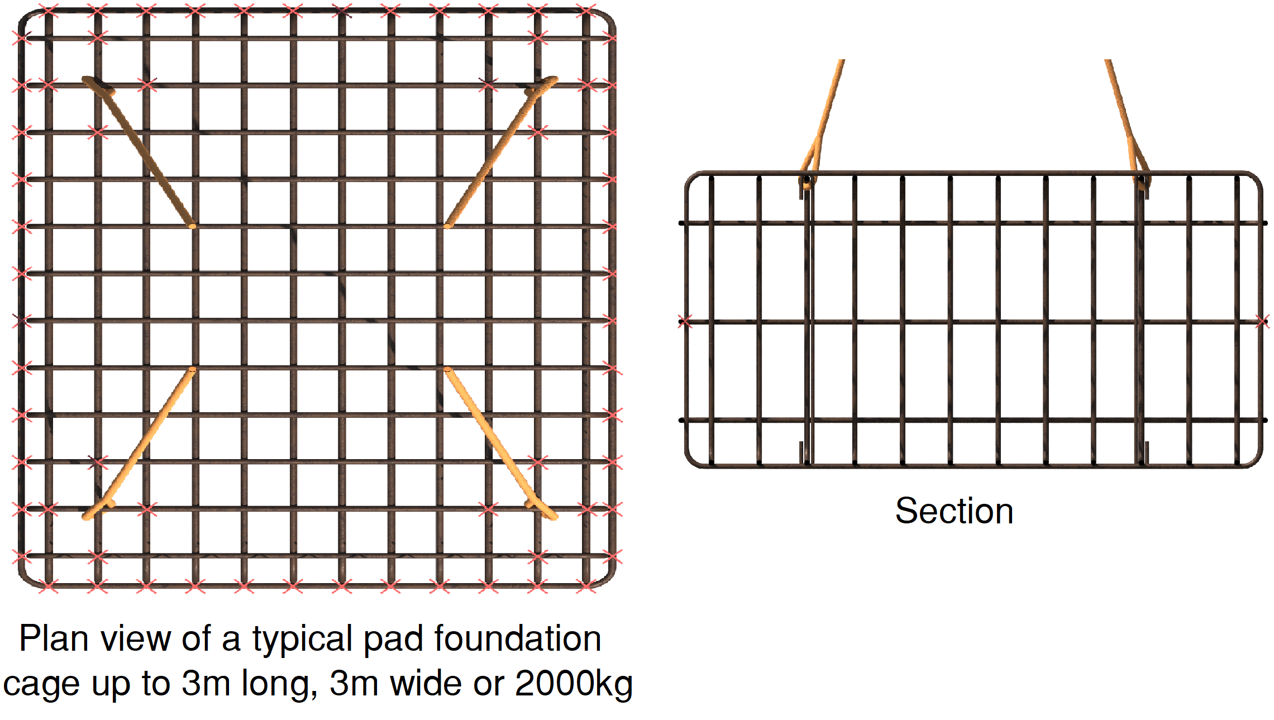 |  | Slinging methodology:  - Check cage has TW confirmation of ‘able to lift’  - Attach 4 leg chain sling to hook block of crane.  - Attach hooks of chain sling to identified lifting points as per TW design for the cage.
Lift Category: | Basic
Dimensions of load: | Various dimensions over assorted designs: _mm [w] x _mm [h] x _mm [l]
Weight of Load | Various weights over assorted designs _ t
Lifting accessories used with weights of accessories: | From hook block >  4 Leg chain slings WLL 8.4 t @ 103kg  Gross weight inc. 10% FOS: _ t [ru] | WLL x Mode Factor | Resulting SWL
 |  | 4 leg chain slings as per design use | 8.4 t over all accessories stated
Alternative methodology: | Various methodologies can be used, but all must have gone a TW’s approval process by TWC. [Temporary Works Coordinator]
Safe lifting considerations: | - Ensure the attachment points for the accessories have been clearly identified and that a TWC approval for lifting is in place.  - Check attachment points and surrounding areas for any loose tying wire connections. If found inform the Lift Supervisor and do not lift.  IF UNSURE OF ATTACHMENT CONSULT THE LIFT SUPERVISOR FOR ADVICE.  - Prefabrication area to be as close as possible to install area to negate lifting the load across project. Minimise distance to be travelled with the beams section.  - When locating beams in trench or foundation scenarios ensure there is sufficient space around the beam and adjacent area for safe access to allow placement without putting installation operative at risk of crushing.  - Ensure there is easy access to the attachment points to allow safe removal of accessories

Loads description: Template
Slinging methodology:

.
Lift Category: | Basic | Intermediate |  | Complex
Dimensions of load:
Weight of Load
Lifting accessories used with weights of accessories: | From hook block >  Gross weight inc. 10% FOS: t [ru] |  | WLL x Mode Factor |  | Resulting SWL
 |  |  |  |  | over accessories stated
Alternative methodology:
Safe lifting considerations:

